**SALES AND INVENTORY MANAGEMENT SYSTEM FOR GANGA ENTERPRISE IN NANYUKI**

**STEPHEN MURICHU MUNUHE**

**BMCS/213J/2018**

**SUPERVISOR: DR. HADULO**

**Research Project Submitted in Partial Fulfillment for the Degree in Bachelor of Science in Mathematics and Computer Science of Technical University of Mombasa.**

## DECLARATION

**Student**

This project is my original work and has not been presented for a degree in any other University for any level of award.

Students Name: __________________________________________

Sign __________________________________ Date _____________________

**Supervisor**

I confirm that the work reported in this project was carried out by the candidate under my supervision.

Name: _______________________________________________

Sign: _______________________ Date: _____________________________

## DEDICATION

This project is dedicated to my mother who has never failed to give me financial and moral support, for giving me all needs during the time I developed this system and for teaching me that even the largest task can be accomplished if it is done one step at a time.  
I dedicate this Project to all the people who have worked hard to help me complete this project.

## ACKNOWLEDGEMENTS

I express my gratitude towards family members and friends who have directly or indirectly contributed toward the successful execution of this project.

## 

## ABSTRACT

The retail business vision is to maximize profit from customer satisfaction and loyalty towards the store by providing more personalized service for the customer. However, retail business is also easy to lose its possible customer if they do not have sufficient stocks in the store. Thus, in this paper, I have identified problem related with inventory in one retail store in Nanyuki known as Ganga Enterprise. The major problem of the store is they do not have proper inventory control system in guiding and managing their sale and inventory level of the store.

By proposing Sale & Inventory Management System to the store as the replacement of old manual ways, the project aims in providing system with enhanced and more flexible functions to the store. The objective of the system is to provide functions in managing goods in the store more efficiently. In order to achieve the objectives derived, the scope of the project will focus on the aspects such as database, report generating, quality control and point of sale of the store. Besides, the development of system will be web-based application.

In developing the system Rapid Application Development (RAD) prototype is chosen. The expected result of the system is that the user interface to be developed will be user-friendly so that it can be handled easily by people with no IT background. Besides, the system is also expected to serve its functions and help Ganga Enterprise in reducing time and paperwork in managing their inventory.

**TABLE OF CONTENTS**

Contents

DECLARATION 2

DEDICATION 3

ACKNOWLEDGEMENTS 4

ABSTRACT 5

CHAPTER 1 INTRODUCTION 9

1.1 PROJECT BACKGROUND 9

1.2 PROBLEM STATEMENT 10

1.3 OBJECTIVES 10

1.4 RESEARCH QUESTIONS 11

1.5 SIGNIFICANCE OF STUDY 11

1.6 LIMITATIONS OF STUDY 11

1.7 SCOPE OF STUDY 12

1.8 ORGNISATION OF STUDY 12

CHAPTER 2 LITERATURE REVIEW 13

2.1 SALES AND INVENTORY MANAGEMENT SYSTEM: HISTORY AND CONCEPTS 13

2.2 SIMILAR SYSTEMS 14

2.4 SUMMARY 16

CHAPTER 3 METHODOLOGY 17

3.1 INTRODUCTION 17

3.2 RESEARCH DESIGN 18

3.3 SYSTEM DEVELOPMENT METHODOLOGY 19

3.4 SYSTEM REQUIREMENT ANALYSIS 19

3.5 DATABASE DESIGN 23

3.6 TOOLS, MECHANISMS AND SOFTWARE 23

3.7 TESTING DESIGN 24

REFERENCES 26

**LIST OF FIGURES**

Figure 1: Quickbooks 14

Figure 2: ShipStation 15

Figure 3: Brightpearl 15

Figure 4: Rapid Application Development 17

Figure 5: Use Case Diagram 21

Figure 6: Sequence Diagram 22

Figure 7: Database Design Diagram 23

## 

## CHAPTER 1: INTRODUCTION

### PROJECT BACKGROUND

The retail industry is one of the industries that is growing in fast pace where the number of retail business keep on increasing from time to time in order to meet the demand from consumers of specified areas. There are different types of retail shops available for consumer to choose ranging from hypermarket to mini market according to their convenience. Most of the shops can be found in residential areas, streets, or in a shopping mall. Basically, retail store sells wide range of goods and services from wholesaler or supplier to the end-user. Thus, the nature of retail business required a good management of inventory level in order to meet the demand of the customers.

The traditional way retailer keeps their sales and inventory details is in spreadsheets which are not effective anymore when the size of the shop gets bigger. This is because more items will be made available in a larger quantity, thus tracking the sales made with inventory level in the shop would be complicated and time consuming for the retailer. Besides, the situation gets worst when the retailer does not have proper method to determine items purchased by their customers.

Thus, this project will provide solution for retailers that are still using traditional way in keeping their inventory data like Ganga Enterprise by creating inventory system. Sales and Inventory Management System is a web-based system that provides the shop structure for maintaining and controlling goods to be stocked. The approach of Sales and Inventory Management System is commonly used to avoid product overstock or outrages by integrating daily point of sales with store’s inventory level.

### PROBLEM STATEMENT

Inventory is one of the important departments that must be well managed in order to ensure daily business activities run smoothly. However, Ganga Enterprise still do not realize the importance of inventory management as they are not equipped with the system in running their business. As a result, the security level of all data, documents and anything that related to daily transaction and inventory is very low. A lot of documents have been kept for each good and for each supplier which consume a lot time and not effective for future references. In addition, due to poor sales and inventory management, Ganga Enterprise also face problems in identifying the quantity sold for each item per day and available inventory level of the items. Existing inventory management also does not provide any means in detecting expired date for food-based products such as milk, bread, flour and etc. Failure to identify the expired date of certain products causes the store to incur losses on those items.

Current system used by stores do not have the capability of generating report on point of sales at the end of the day. Thus, there is no proper guideline in making reports in the store’s log book which result in different kind of reports being prepared each time. The simple report which is about the total sales of the day is determined based on amount of money in the cashier deck does not provide any input for the owner to make the right decision regarding the business operation. In case of there is short of cash in the cashier desk or any stolen cases, the owner cannot detect it as the current system does not have database to store the total sales of the day.

### OBJECTIVES

As most existing system provides limited functions to the user, thus this project will contain enhanced and more flexible functions to the store. The objectives include:

#### General Objectives

1. To provide function to manage goods in the store more efficiently. Basic functions such as ‘add’, ‘delete’, and ‘update’ for data management will be made available.
2. Filling system in managing all transactions and documents that are relevant as the aid in the stock tracking routines.

#### Specific Objectives

1. To automatically generate weekly report on sales and inventory activities
2. To provide notifications on the goods’ expiring date for clearance activity.
3. To generate receipt with proper format for customer references
4. To provide point of sales for each day

### RESEARCH QUESTIONS

1. How do Ganga Enterprise manage the store?
2. How do Ganga Enterprise get the best value for money with inventory control software?
3. What results can Ganga Enterprise expect from using inventory management software?
4. What challenges are needed to be solved by inventory management system?

### SIGNIFICANCE OF STUDY

This system that will be developed will contain database that enable data storage and retrieving of each transaction and data about inventory of each item in the store, manage the product releases and storage and summarize point of sales. This would generate a faster improvisation of work with less time and effort. As the concept of Sales and Inventory Management System is to reduce paper works and ineffective ways of managing inventory, this system is expected to assist in making the right decision in the process of managing inventory aligned with the sales level in the store.

### LIMITATIONS OF STUDY

Due to time constraints, the project has the following limitations:

*Lack of decision support element -* The system does not analyze the data in capture in the database such as provide the patterns of customer buying behavior to the user but just have the capacity of retrieving the data in the form of report.

### SCOPE OF STUDY

Within the boundary of this project, the system aims in having the following aspects:

* Database - has two parts in it, temporary transaction database and master database. The data in a master database will be updated according to the temporary database at the end of each day.
* Report- generates daily and weekly report to know the number of inventories in the products.
* Quality control - to check the expired date of the products.

The development of the system will be web-based. In order to implement the system, the first thing is to collect information about the products and requirements from the store owners. The user interface and the backend of the system also will be developed.

The second half of the project will be mainly on implementing and testing the system until it is completed.

### ORGNISATION OF STUDY

Time and scope are interrelated constrains in a project development. In development of the system, the scope has been narrowed down to only inventory control through daily sales and this will give the developer enough time to conduct preliminary research and develop the project.

Research also includes analysis on the literature review for the developer to understand subject domain in detail with realistic time frame. Keeping the project focused and having clear framework are important in minimizing the failure risks of the project.

## CHAPTER 2 LITERATURE REVIEW

### SALES AND INVENTORY MANAGEMENT SYSTEM: THEORETICAL LITERATURE

Each day, millions of people take part in countless sales transactions across the globe, creating a constant flow of value which forms the backbone of our economies. In general, sales mean a transaction that takes place between two parties where the buyer receives goods (tangible or intangible), service or assets in exchange for money. Thus, the process requires each party to give up something in return for something valuable for them. On the other hand, inventory means the raw materials, work-in-process goods and finished goods that are considered to be the portion of a business’s assets that are ready for sales. This explains that, business needs inventory available to make sales to the customer in return for money which will generate the profits.

There are two kinds of problem that are faced by business in managing inventory level which are high inventory and low inventory. Holding a high level of inventory for long periods of time is not usually good for a business due to costs incur for inventory storage, obsolescence and spoilage. On the other hand, low level of inventory is not good either as the business may face the risk of losing potential sales and potential market share as well. In an attempt of resolving inventory problems, the solution lies on efficient inventory management.

Tim Crosby (2012) in his study on ‘How Inventory Management Systems Work’ stated that inventory management system is the rule in knowing which products are selling and which are taking up shelf space for enterprises as well as smaller businesses and vendors. The system balances the goal of ensuring customers always have enough of what they want against a retailer’s financial need to maintain as little stock as possible (Tim Zierden,2009). Thus, the ability to track sales and available inventory, communicate with suppliers in near real-time and receive and incorporate other data such as seasonal demand must available in the modern inventory management systems.

According to Anton Dolinsky (2010) on his article about ‘Barcodes, sales and inventory control’ stated that in the earliest days of inventory keeping, in order to forecast future needs, the merchants wrote down purchases or looked down at how many units were gone at the end of the day. However, this practice seems to be difficult to carry out after the Industrial Revolution as the mass production became the main goals of business together with improving customer experiences at the point of sale. In the early 1930s, a team from Harvard University designed the first modern check-out system that used punch cards that corresponded with catalog items. In 1960s, the emerged of affordable laser technology development brought hope in reviving the concept. Then modern bar code or Universal Product Code (UPC) was born and caught on just before the 1970s. As a result, the power of UPC codes to help track and manage inventory improved exponentially when the computing power became better at the same time.

As the technology development advance, another new technology for inventory tracking has made its way into stores, warehouses and factories in recent years (Edward A. Silver, 2007). Radio frequency identification (RFID) uses a microchip to transmit product information to a scanner or other data collective device. Thus, the constant ‘beep, beep, beep’ of bar codes being scanned at the check-out lane represents the modern inventory management systems of stock tracking.

### 2.2 SIMILAR SYSTEMS

Below is list of similar systems:

**Quickbooks (** [**https://quickbooks.intuit.com/global/**](https://quickbooks.intuit.com/global/) **)**

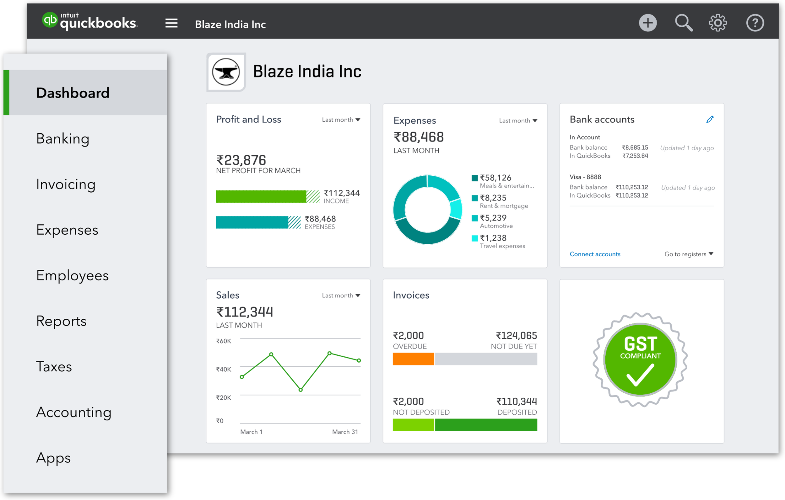

Figure 1: Quickbooks

QuickBooks Desktop Enterprise is a widely-used accounting package designed for small to mid-sized businesses.

**ShipStation (**[**https://www.shipstation.com/**](https://www.shipstation.com/)**)**

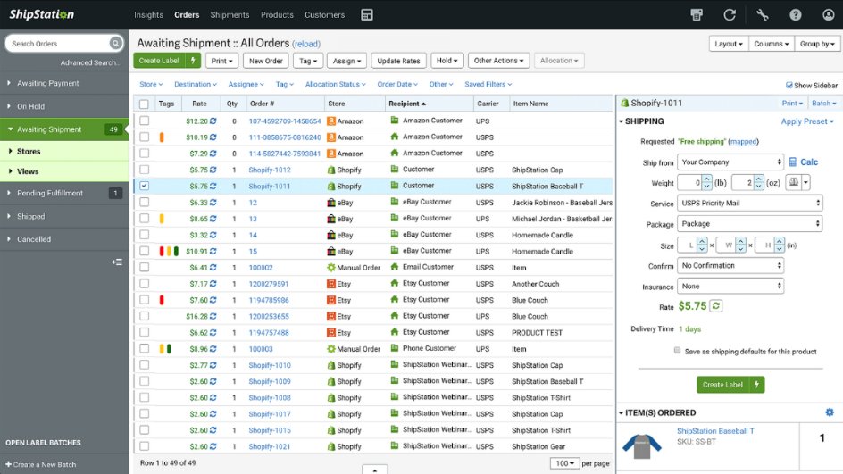

Figure 2: ShipStation

ShipStation is an order fulfillment, inventory management, and shipping hub for eCommerce businesses. It allows users to import, manage, and ship orders from the ShipStation hub, which can coordinate multiple online sales channels and multiple carriers.

**Brightpearl (**[**https://www.brightpearl.com/**](https://www.brightpearl.com/)**)**

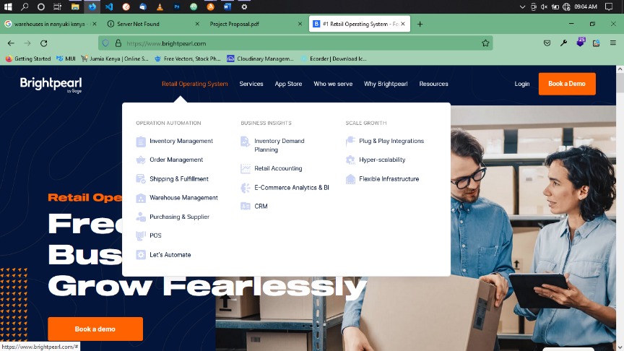

Figure 3: Brightpearl

Brightpearl’s retail operations platform is designed to handle peak trading, integrates with the full retail tech ecosystem, and is omni-channel native.

Some business owners using these systems complaints are:

* In availability of documentation.
* Sluggish and unresponsive user interface.
* Hanging of the system while importing large volumes of order.

This system aims at solving these problems by:

* Creating a responsive user interface.
* Providing documentation for the users.
* Using high level programming language to enhance speed in performance.

### 2.4 SUMMARY

In today’s world every business tries to strike a balance in inventory between what is needed and what is demanded, considering the major factor of cost cutting/reduction. Inventory management focus on the capacity of the inventory, the place in which it is located so that one can use it when needed, the supply chain management of the raw materials and goods.

As the concept of Sales and Inventory Management System is to reduce paper works and ineffective ways of managing inventory, this system is expected to assist in making the right decision in the process of managing inventory aligned with the sales level in the store.

## CHAPTER 3 METHODOLOGY

### INTRODUCTION

In developing the system, developer chooses to use one of ‘rapid application development (RAD)’ – based methodology categories in ensuring smooth user and developer with different IT background. RAD- based methodology allows in adjusting the SDLC phases in getting some part of the system being developed quickly and into the hands of the users. In this way, the users can better understand the system and suggest revisions that bring the system closer to what is needed.

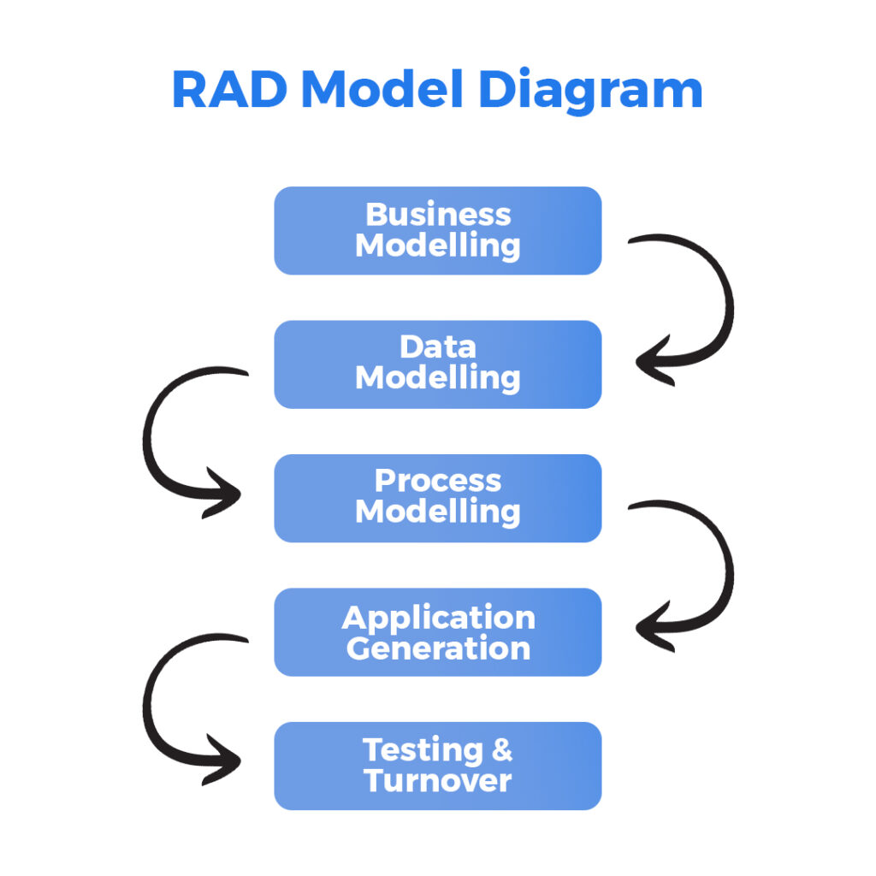

**Figure 4: Rapid Application Development**

As the system contains many modules binds together to work as a complete application, phased development- based is the best methodology to anticipate this problem where it breaks an overall system into a series of versions, which are developed sequentially. Thus, system prototype will be developed based on one module after another. The analysis phase identified the overall system concept then categorizes the requirements into a series of versions. Besides, visibility of layout in web-based application is one of critical part. This allows the developer to identify navigation and usability problems when developing one of the modules before spending a lot of time developing the entire system completely. Once version 1 is implemented, work begins on version 2. Additional analysis is performed based on the previously identified requirements and combined new ideas and issues that arose from the user’s experiences with version 1.

The advantage of phased development- based methodologies of quickly getting a useful system into the hands of users provides business value sooner to the user. Moreover, because users begin to work with the system sooner, they are more likely to identify important additional requirements sooner. These are some of the reasons why the author chooses this methodology for development process.

### RESEARCH DESIGN

These will include the tools that will help the developer to navigate from requirements to a working system. They will help transform requirements into a working system implementation. Software analysis and design is the intermediate stage, which will help human-readable requirements to be transformed into actual code. They will include:

**Data flow diagrams** - Data flow diagrams will be used to shows how data information flows within the system. This will help in depicting in coming data, outgoing data, and stored data at various levels of the registration system.

**Flow charts** - Flowcharts will be used to break down and present process in terms of simple step diagrammatically.

**Entity relational diagram** - This will be mostly be used in database. It will be used to show real world entities and their relationships. ER Model creates a set of entities with their attributes, a set of constraints and relation among them.

**Case diagrams** - this will be meant to show the actors and different roles that they play within the system.

### SYSTEM DEVELOPMENT METHODOLOGY

There are basically four phases in the project activities which comprise of:

***Planning:***

* The problem faced by chosen shop is identified and the solution is proposed
* The objectives and scope of project are defined clearly
* The project activities are planned according to the time frame

***Analysis:***

* Data is gathered and analysis on literature are done

***Design:***

* Project model and prototype are designed
* Diagrams are designed

***Implementation:***

* Coding of project is initiated until the system is completed
* Testing is carried out to test the usability of the project

***Maintenance***

* Handling residual errors and resolve any issues that may exist in the system even after the testing phase

### SYSTEM REQUIREMENT ANALYSIS

#### Functional Requirements

* + - * Log In
      * Process sale

Allow user to scan items purchase by each customer. The system will display the description of the items and process the total sales and generate receipt for the customers.

* Tracking inventory level

Admin able to track the inventory level of each item in line with the sales made.

* Update database

Allow admin to update the inventory data in the database that will be used when processing sale.

* Generate report

Reports on daily, weekly and monthly sales of the store will be generating so that the owner can view the performance of the business and take appropriate actions.

#### 3.4.2Non-functional requirements

* Performance Requirements
* This system should not take more than 5 seconds to load information and it should not delay more than 2 seconds for user respond.
* Security Requirements
* Not all staff can access the system apart from the staffs that are responsible in processing customers’ sale at the cashier. The sales information is confidential and only accessible by the admin.
* Cultural and Political Requirements
* No special cultural and political requirements are anticipated

#### 3.4.3Unified Modelling Language

##### 3.4.3.1 Use case Modelling

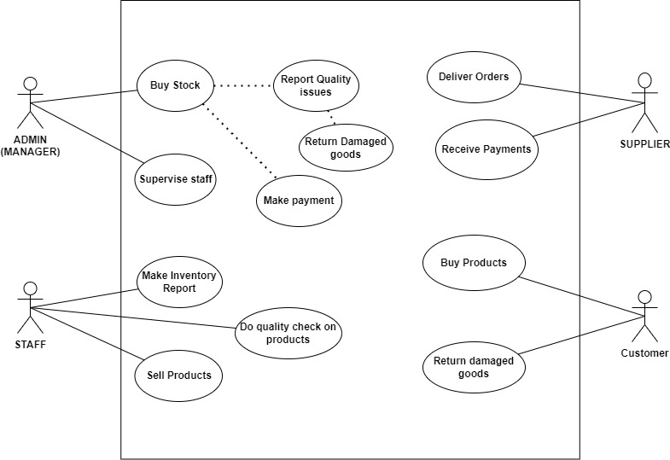

Figure : Use Case Diagram

##### 3.4.3.3 Sequence Diagram

#### 

Figure : Sequence Diagram

### 3.5 DATABASE DESIGN

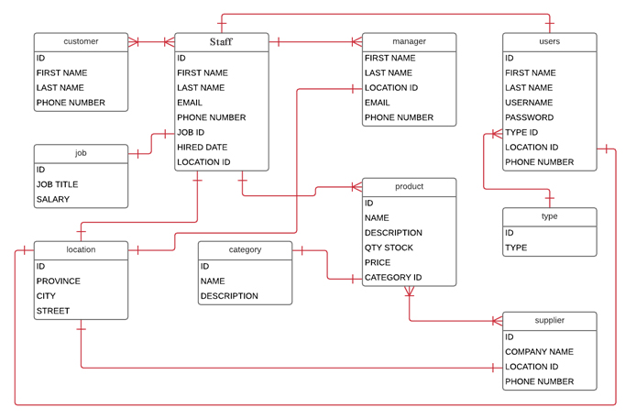

Figure : Database Design Diagram

### TOOLS, MECHANISMS AND SOFTWARE

In the second part of the project, tools that are used to develop the system are as follows:

1. ***Microsoft Visual Studio***

Microsoft Visual Studio is an integrated development environment (IDE) from Microsoft. It is used to develop computer programs, as well as websites, web apps, web services and mobile apps.

1. ***PostgreSQL***

PostgreSQL is used as the primary data store or data warehouse for many web, mobile, geospatial, and analytics applications.

1. ***Diagram Tools (draw.io)***

It is free online diagram software. You can use it as a flowchart maker, network diagram software, to create UML online.

### TESTING DESIGN

Testing is intended to show that a program does what it is intended to do and to discover program defects before it is put into use. When testing the software, the developer will execute a program using artificial data, check the results of the test run for errors, anomalies, or information about the program non-functional attributes.

Testing this web application will involves;

**Unit testing** - Unit testing is the process of testing various web components, such as methods or functions. They are the simplest type of component. Your tests should be calls to these routines with different input parameters.

**Component testing** - Testing composite components should therefore focus on showing that the component interface behaves according to its specification.

**Acceptance testing** - this will be meant to check if the system will perform as expected so as to be accepted by the targeted people.

**Security testing** - security testing will involve testing the system to situate that it does not allow data integrity being compromise neither performing of task that are not at your domain.

**Reliability testing** - this will involve checking the probability of failures form the system. This will help in predicting the future of the system if it will perform optimally or not.

**System testing** - System testing during development involves integrating components to create a version of the system and then testing the integrated system. System testing checks that components are compatible interact correctly and transfer the right data at the right time across their interfaces.

**Release testing** - Release testing is the process of testing a particular system before the system is deployment to its intended for use outside of the development team. Normally this testing will involve a team of developers and some random client from a related field so as they can do the testing.

**Validation** - It will involve checking correctness of system result after execution. This will depend on the correctness of inputs since will only it accepts only the required inputs. Validation will involve checking the correctness and acceptable set of inputs, which will be specified to the user.

## REFERENCES

1. Deloitte (2012), The Changing face of retail Retrieved 18, Jun 2013 from  
   <http://www.deloitte.com/assets/DcomUnitedKingdom/Local%20Assets/Documents/Industries/consumer%20Business/uk-cb-store-of-the-future-report.pdf>
2. Tim Crosby (2007), How Inventory Management Systems WorkRetrieved 22, Jun  
   2013 from http://money.howstuffworks.com/how-inventory-management-  
   systems-work1.htm
3. Wikipedia (2013), Inventory Management Software Retrieved 22 Jun 2013 from  
   <http://en.wikipedia.org/wiki/Inventory_management_software>  
   Anton Dolinsky (2007), Barcodes, sales and inventory control Retrieved 22 June 2013 <http://www.almyta.com/InventoryManagementHistory4.asp>
4. EvrenSahin & Yves Dallery (2010), The impact of the use of RFID on Supply chain operations Retrieved 30 July 2013 from http://ebajic.free.fr/RFID%20Forum/Papers%20submitted%20but%20not%20presented/A%20LITERATURE%20REVIEW%20ON%20THE%20POTENTIAL%20OF%20THE%20RFID%20TO%20TACKLE%20INVENTORY%20MANAGEMENT%20ISSUES.pdf.